## eProject Handikrafts

1. **Acknowledgement**

We are very grateful to you for sending us this project asignment which has been very interesting to work with and we have learned a lot after.

We would like introduce the members of project :

**Teacher guide :** Quan Nguyen Tung

|  |  |
| --- | --- |
| **ID Student** | **Name Student** |
| Student1091183 | Nam Vu Hai |
| Student1091225 | Thanh Ngo The |
| Student1091196 | Dat Nguyen Manh |

II. **eProject Synopsis**

Our Project consists of two parts :

1. **Source Code Website**

We send enclose with this Document

1. **Document** 
   1. eProject Design
   2. User Guide
   3. Deverloper‘s Guide

**III. eProject Analysis**

**1. eProject Design**

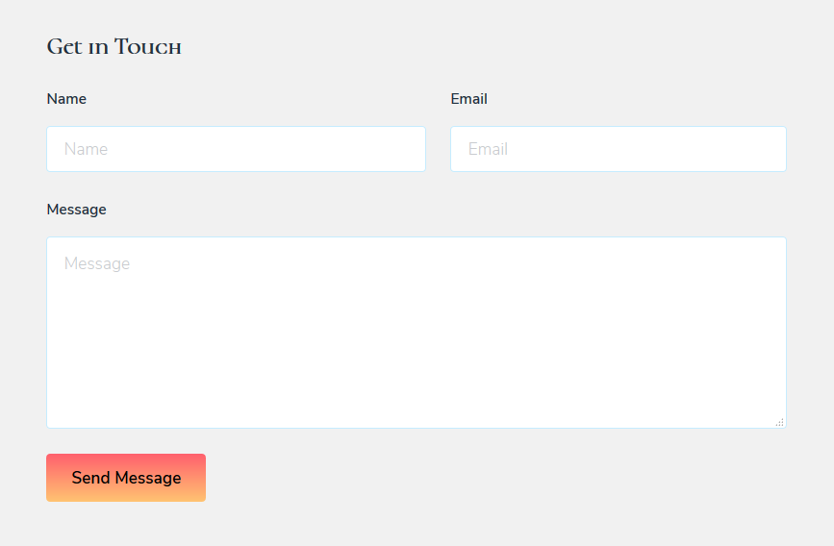

Contact us

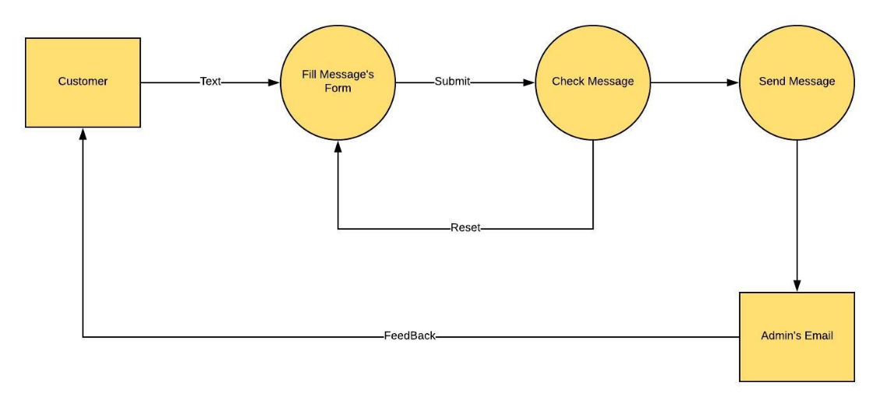-DFD

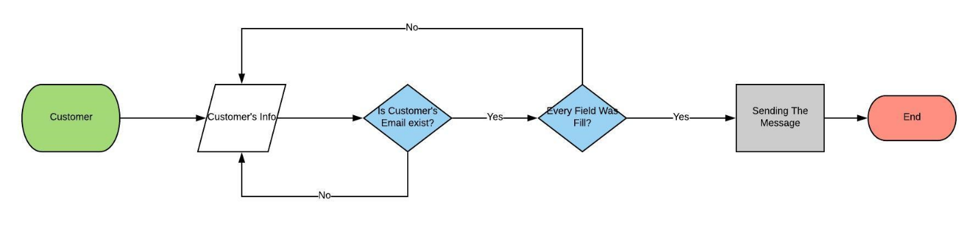**-Flow chart**

**2. User Guide**

**a. Our menu/navigation bar**

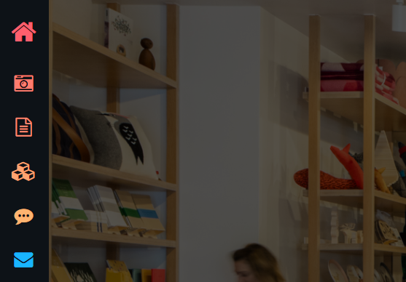

Our menu

On the left of every page of our site is our navigation bar / Menu, which icons are symbols for the following pages as our Home page , Gallery , Introduction , Products , FAQ , Contact  .

The Icon will be bigger than usual to indicate which page that the user is currently on. Like so…

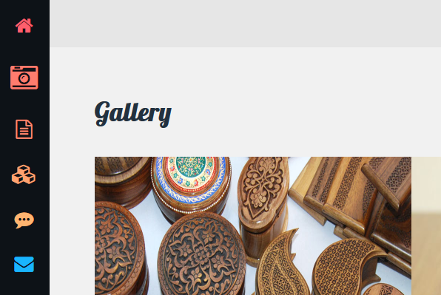

If the user is on the Gallery page then the Gallery Icon should be looking like the picture.

**b. Home Page** 

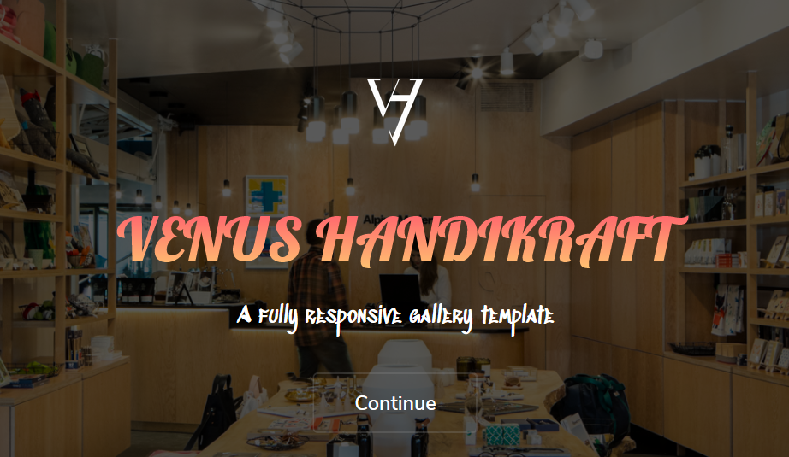

Briefy introduce our site and customers’s orders gallery.

____________________________________________________________

**c. Gallery** 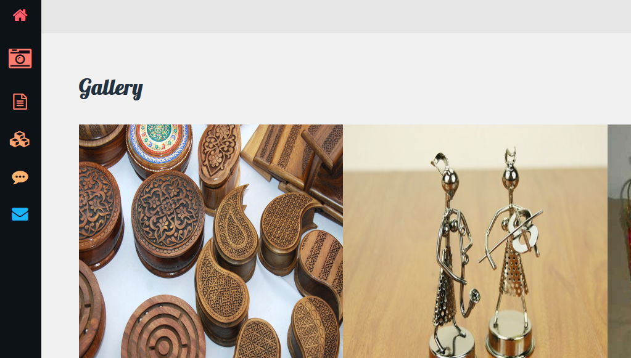

Holds samples from our products that are made by our customers’s own unique demands, no products are the same in styles nor meanings.

**d. Introduction/About us** 

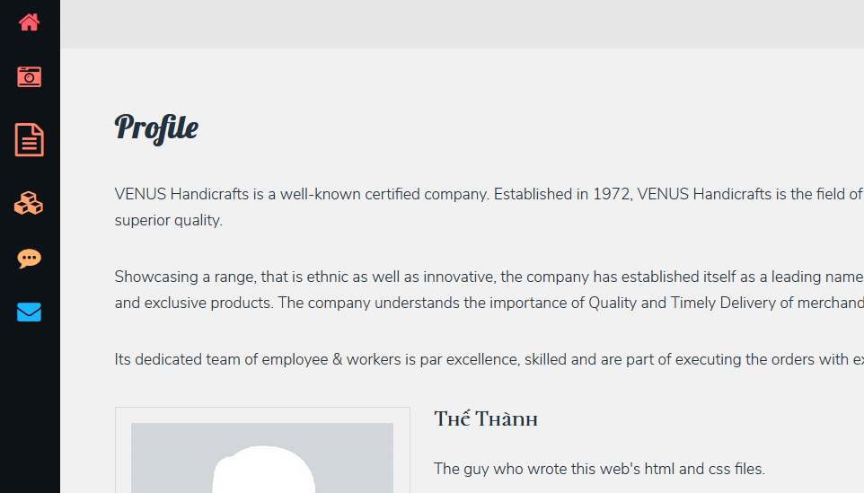

Our company’s profile, a briefly introduction of our staffs, who are we? what are we? what is our utilmate goal? our achievements and how well do we know about our customers.

____________________________________________________________

**e. Products** 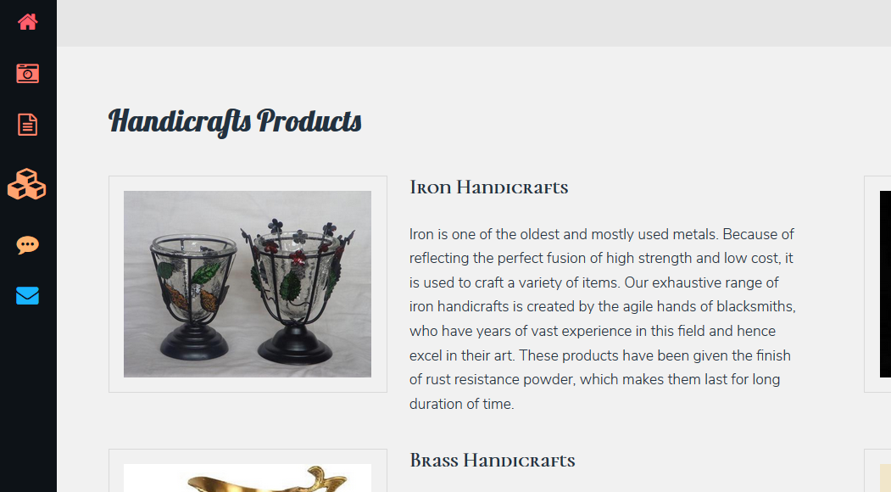

Type of material that customers can choose from for us to make from with there own personal designs, also a little majestic introduction of each type of material for deeper understanding for the customers own personal choices.

**f. FAQ** 

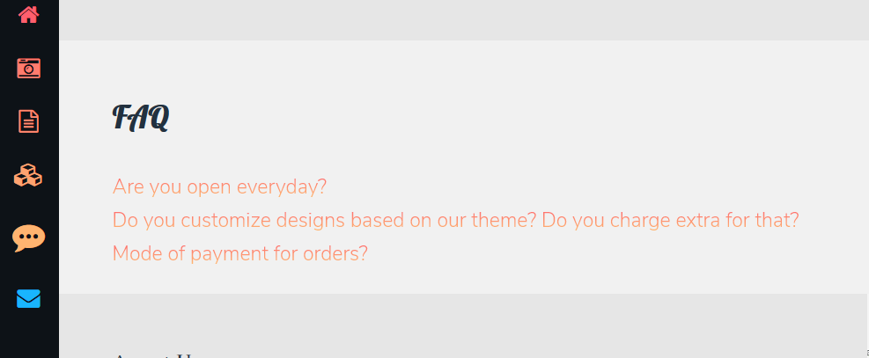

How do we work? **When** do we work? Where am I? …just normal questions beeing asked in a lot of the time, mostly about how do we do things around here. User can just click the question and it’s answer will slide down, just to make it clear which questions are beeing answered.

____________________________________________________________

**g. Contact us** 

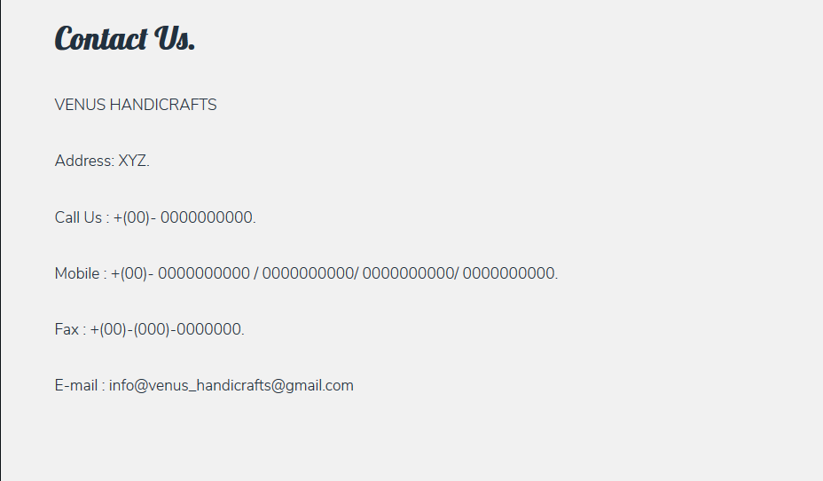

Our contact information. Want to make a compain? Want to ask us about the delivery? Something? Just call us, fax us, email us, however you want to.

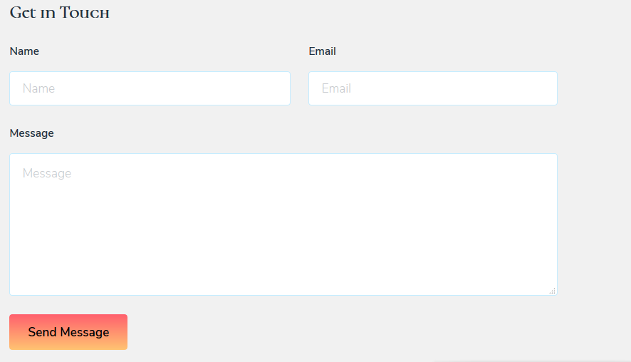

Ok, ok. This is where the user makes their orders. Send us your contact information, delivery location and we’ll send you a form which you can tell us the detail of your orders, it’s design, the material, etc. After receiving your order, we’ll email you that we have confirmed your order and you will receive your product as soon as possible.

____________________________________________________________

**3. Developer’s guide**

In Document we send you has 7 section

1. 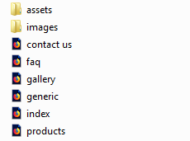*Assets*
2. *Images*
3. *Contact us.html*
4. *Faq.html*
5. *Gallery.html*
6. *Generic.html*
7. *Index.html*
8. *Products.html*

Now , we will go into detail in part :

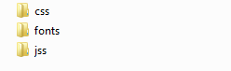**1-*Assets***: Which have 3 differents file:

a. File css

b. File fonts

c. File jss



a.File css:

- The file named font-awesome.min is just a library for our **Navigation bar/Menu**, basicly without it our site’s menu won’t work.

- And our web’s css file ofcourse, which have been commented for easier understanding.

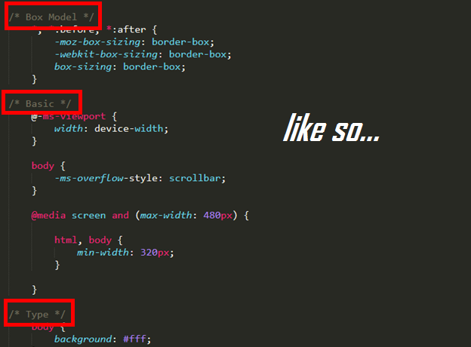

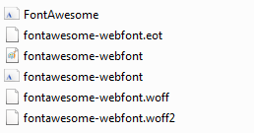

b. File fonts

Basicly, this is just our bootstrap 4-replacement.

c. File js:

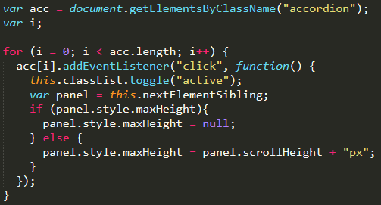

These code only affect our “faq.html” file. The usage is just make the answer of a question slide down when it’s question is clicked by the user. Like so…

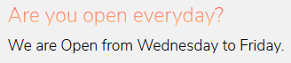

**Clicked!**

**2-*Images***:

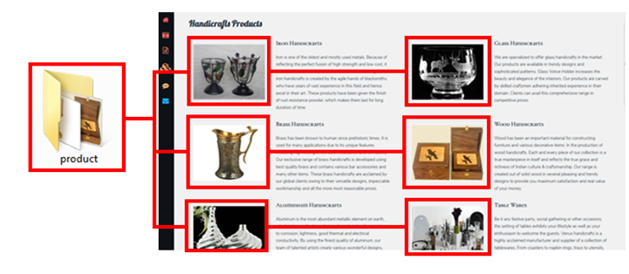

Images in our Products Page

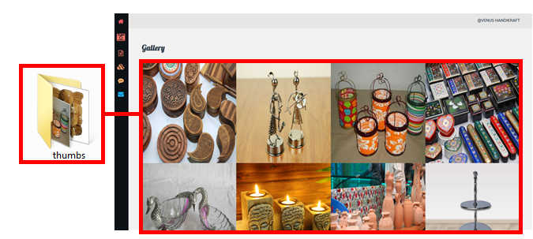

Images in our Gallery Page

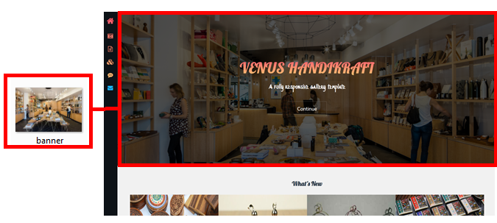

The background image of our Home Page

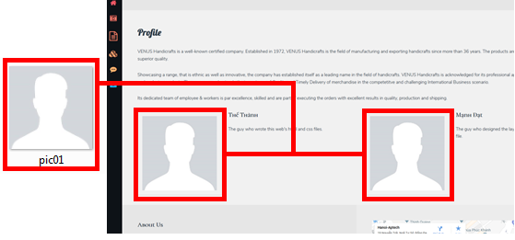

Our profile pictures

